BACKTRACKING
1.n-queen chess puzzle
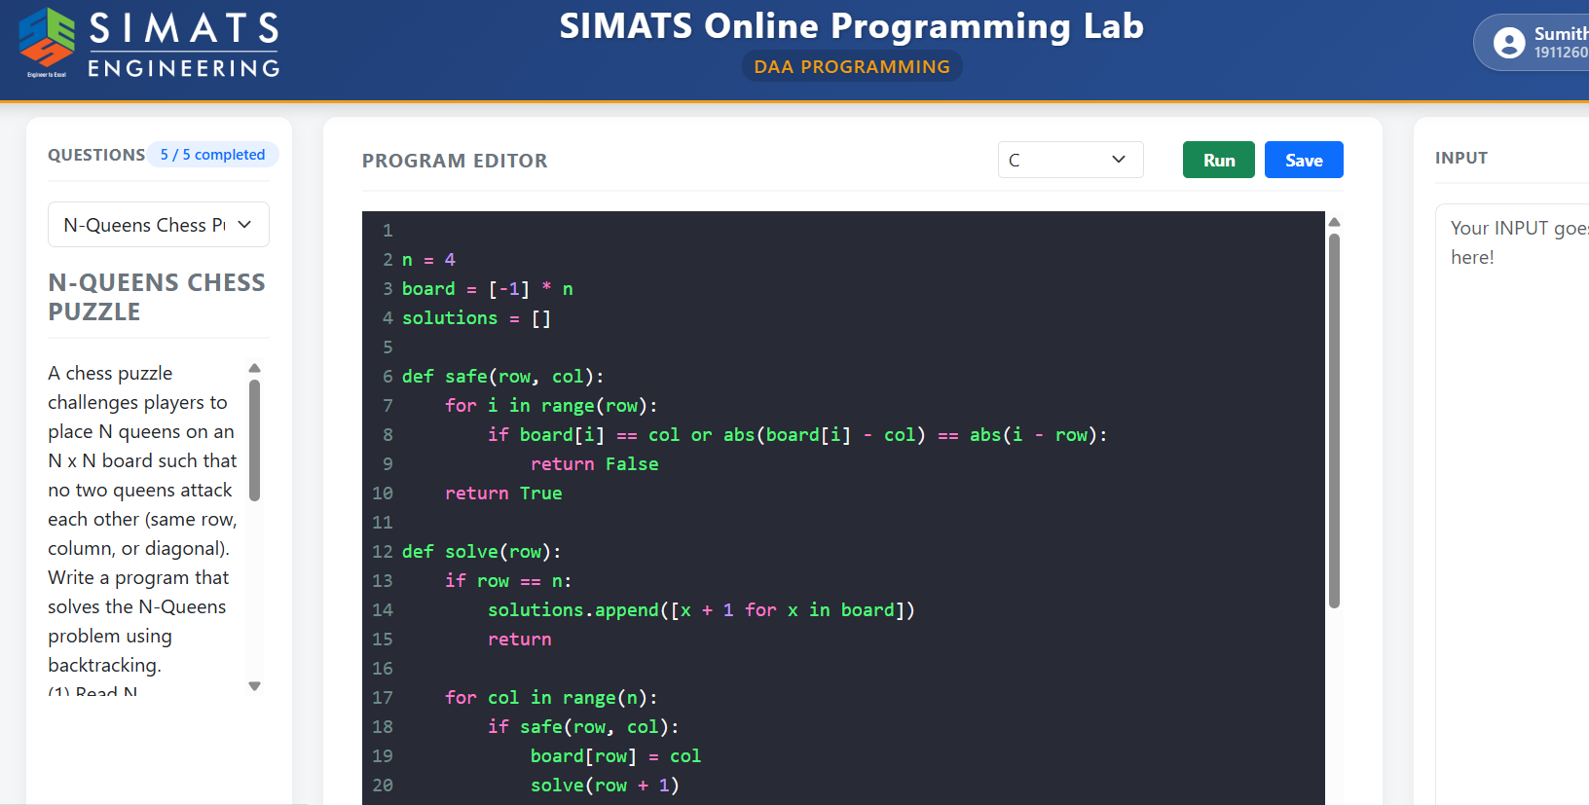
2.sudoku puzzle solver
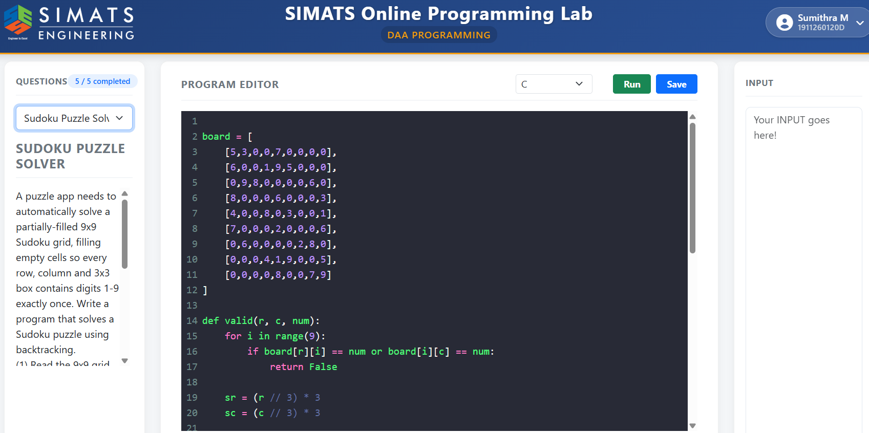
3.warehouse robot maze
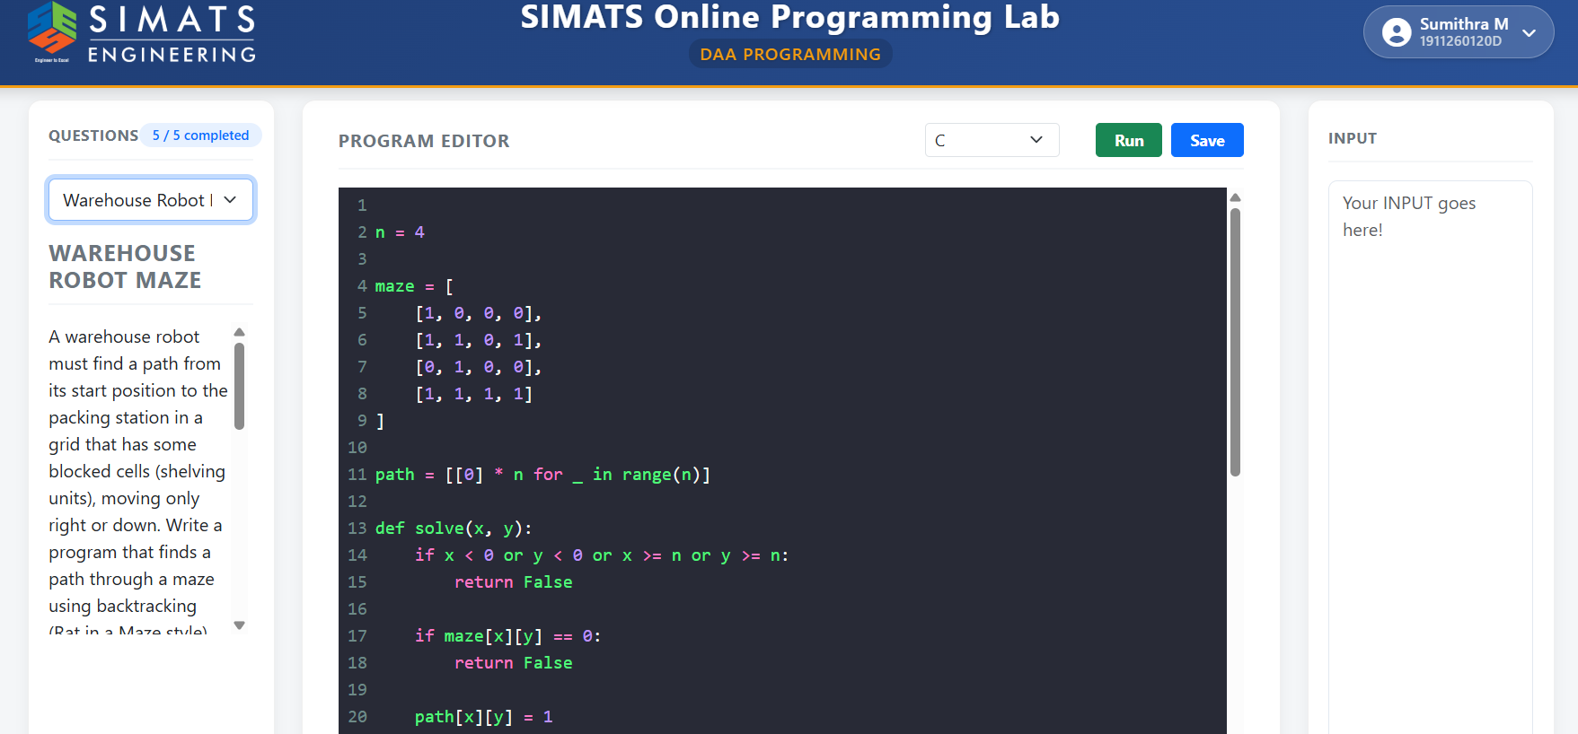
4.tour guide Hamiltonian cycle
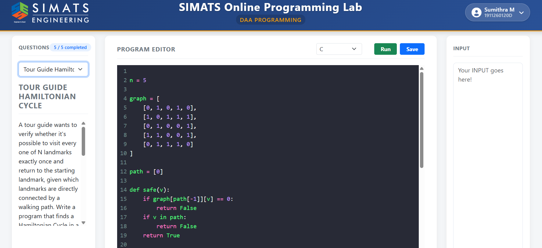
5,cargo exact weight match


